The ARC Alex Timpson Awards 2026

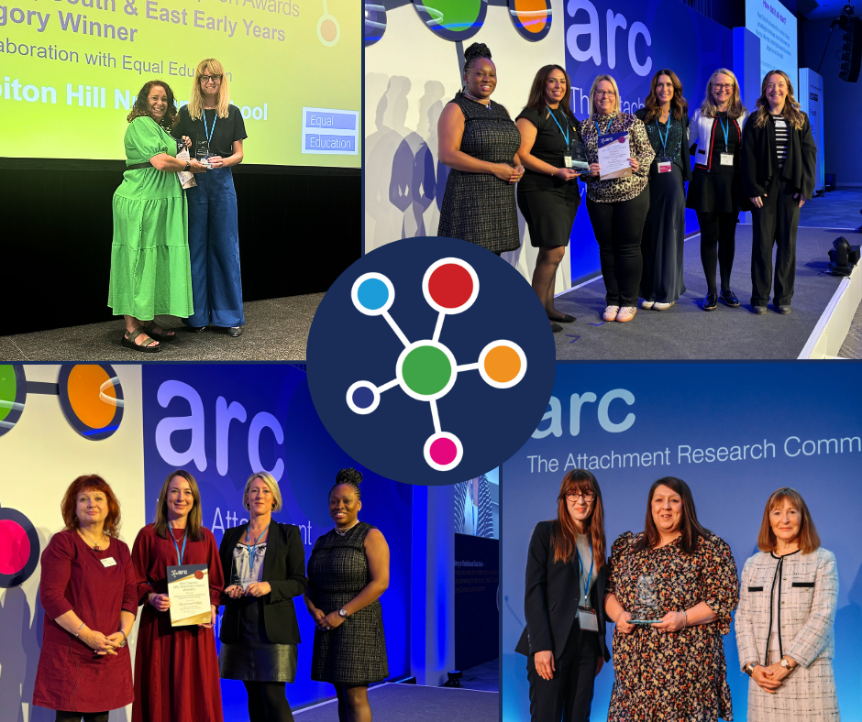

Partners


Equal Education
Equal Education is an award-winning social enterprise that connects qualified teachers with under-resourced young people to provide specialist 1:1 tuition. We work with schools, local authorities, carers and parents to provide bespoke, child-centred provision that supports children who face some of the biggest barriers to learning.

eGov Solutions

eGov Solutions is a market leader in creating a unified platform that bridges the gap between education and social care. This platform is specifically designed to support vulnerable children across all cohorts. By integrating innovative technology with a deep understanding of the challenges faced by these communities, eGov Solutions enables schools and social care organisations to collect and analyse critical data on attainment and attendance efficiently.

The ARC Alex Timpson Awards recognise and celebrate best attachment and trauma aware practice in schools and settings.

Schools are invited to link with their Virtual School Head Teachers to be nominated for the Regional categories below. Nominees will be judged by panels led by the ARC trustees and shortlisted for the Regional ARC Alex Timpson Awards. Winners for each category will be presented within the relevant region. Regional winners will automatically be shortlisted for the National award. Winners for the National award will be announced at the ARC Annual Conference. The regions are:

- Midlands – (NAVSH West Midlands & East Midlands) in partnership with Equal Education
- London & the South East – (NAVSH London, South & Eastern) in partnership with Equal Education
- North West – (NAVSH North West, Northern Ireland, Wales) in partnership with Equal Education
- North East – (NAVSH North East & Yorkshire and Humberside, Scotland) in partnership with Equal Education
- South West – (NAVSH South West) in partnership with E-Gov

Awards will be presented to the school or setting in each category which, in the opinion of the ARC Judging Panel, has made the most significant development in its attachment and trauma aware practice. Judges will look at three main areas: (ambition, scope and impact)* and the form below enables work in these areas to be highlighted. Judges recognise that the development of attachment and trauma practice is a journey, so work in progress is welcome.

There are six categories for the ARC Alex Timpson Awards:
- Early Years
- Primary
- Secondary
- Special/PRU/Alternative Provision
- Post 16
- Collaborative – may be a mix of schools and settings

Dates and Deadlines – Regional Awards

The Alex Timpson ARC Attachment Award is FREE and is open to ARC members and non-members. All nominees must be supported and nominated by their Virtual Head.

Nominations open date: | Tuesday 11th November 2025
Nominations closing date: | Friday 13th March 2026
Date for shortlisted schools and settings to be contacted: | Friday 27th March 2026
Deadline for shortlisted content: | Wednesday 29th April 2026
Please send all nominations to admin@the-arc.org.uk

Dates and deadlines for the National award will be sent to Regional Award winners once all Regional Events have taken place and winners announced.

Shortlisted content

Regional award shortlisted schools & settings will be asked to provide ARC with a selection of photos that represent your school/setting.

National award shortlisted schools & settings will be asked to provide a 2 minute video or PowerPoint presentation that showcases the work of your school/setting.

Regional winners will receive:

- ARC Regional Alex Timpson Awards Trophy
- Certificate
- Ticket to the 2026 National Conference
- Shortlist to the National Awards
- Workshop and/webinar at regional events

National winners will receive:

- ARC National Alex Timpson Awards Trophy
- Certificate
- £1000 Grant (subject to approval)
- Workshop at the following National Conference

Submissions

The Virtual School Head Teacher nominates a school or setting by filling out the form below. As they complete the form they will need to discuss it with the nominated school or setting. Forms are then to be returned to admin@the-arc.org.uk for judging.

Once nominations have been received, schools or settings from each region will be shortlisted and the shortlists will be asked to provide ARC with a 2-minute film OR a PowerPoint Presentation. The presentation must showcase and explain the attachment and trauma aware work you are doing in your school. Your presentation will be showcased at the ARC 2026 Regional Conferences.

The shortlisted schools or settings will be invited to the ARC Regional Conferences, where the winner from each category will be announced. Winners from each category will then be shortlisted for the National Awards and invited to the ARC National Conference where the overall winners will be announced.

Nomination Form

The form is completed by the Virtual School Head Teacher. The Virtual School Head Teacher should work with the nominated school to respond to the questions below and takes overall responsibility for the submission. All fields are mandatory, should there be any blanks then the application will not be considered by the judges.

Supporting materials – If you wish to provide any supporting materials please attach and clearly label all documents within an email along with this form. The judging panel would be happy to receive anecdotal evidence e.g. quotes or anonymised case studies and data e.g. improved well-being, attendance, behaviour. Please note that judging panels may also take the ARC Matrix in to consideration.

In submitting your application you are agreeing to have your work shared on the ARC website and if you are a winner you are agreeing to host and present a workshop at the following Regional conference. National winners are also agreeing to host and present a workshop at the following National Conference.

If you have any questions about the nomination process, please contact admin@the-arc.org.uk

Virtual Head Teacher Nominator Details – Your details
Name:
Email Address:
Contact Phone Number:
Virtual School Local Authority:
Region (delete as appropriate) | - North East, Scotland  - North West, Northern Ireland, Wales  - Midlands  - South West  - London & South East
Supporting statement from Virtual Head [MAX 250 words]

Nominee Details – School or setting details

Name of School or Setting
Name of Contact
Job Title
Contact Email Address
Contact Phone Number
Category

Submission Summary

- Please explain the context of your school, its cohort and the community it supports [MAX 200 words]
- Please tell us something about your school or setting; why you chose to develop attachment and trauma aware practice and the ambition behind the work [MAX 250 words]
- Please provide us with a summary of what the school or setting has done to improve their attachment and trauma aware practice. Please describe what was done within the school or setting and who else you included in the work e.g. parents, carers, other schools [MAX 250 WORDS]
- Please provide us with a summary of what impact this had on the school or setting. Impact may be described quantitatively - changes in key data over time or qualitatively using quotations, case studies etc. Both approaches are valuable [MAX 250 WORDS]
- Please provide us with information about how the school or setting has or intends to share its work and support other partners/agencies/settings to be attachment and trauma aware. [MAX 250 WORDS]
Virtual Head Teacher’s signature
Nominations open date: | Tuesday 11th November 2025
Nominations closing date: | Friday 13th March 2026
Date for shortlisted schools and settings to be contacted: | Friday 27th March 2026
Deadline for shortlisted content: | Wednesday 29th April 2026
Please send all nominations to admin@the-arc.org.uk

